DATE OF UPDATE: May 18, 2026
Hi Team,
Sharing a quick set of real-time updates to keep everyone aligned as we move through Q4. Please read carefully—there are a few important changes that impact quoting and execution.
Key updates (as of May 15):
- Quoting
The channel can now quote all Panther Lake SKUs, including 4xe configurations.
- Special Pricing / CPS / CAS
  - All new submissions will now expire July 30
  - For CAS approvals currently ending June 30, please work with your CE now to extend to July 30 where needed
- SKU eligibility changes (effective May 18)
The following SKUs will no longer be eligible for Special Pricing, CPS, or EDU evergreen offers:
Laptop 15” Intel 8th Edition:
These SKUs will remain eligible for Deal Registration, and any already approved SP/CPS discounts will be honored.
- U5 / 16 / 256
- U5 / 16 / 512
- U5 / 32 / 256
- U5 / 32 / 512
- Invoicing reminder (important)
→ Product must ship and invoice by the expiration date of the CAS/Offer/Promo
→ No exceptions—please plan deals accordingly
Availability update
- Updated table attached for Panther Lake SKUs, including Ashwell (Laptop 13” Intel 1st Edition)
- Now includes exact Intel processor details to support quoting accuracy

Bottom line:
Please take action where needed (extensions, deal timing, SKU selection).
As always, reach out if anything is unclear. Appreciate the focus and continued execution.

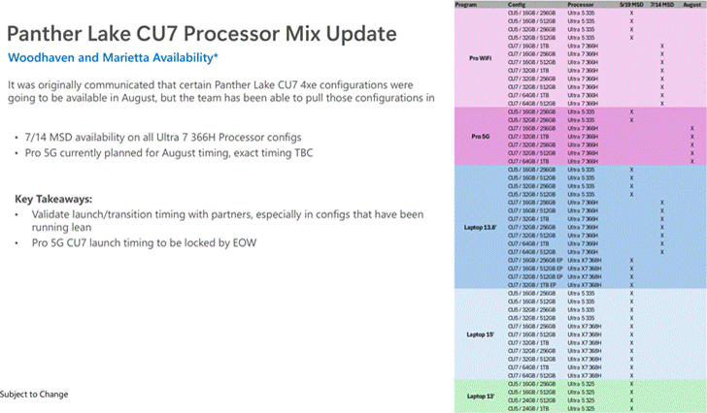

DATE OF UPDATE: May 18, 2026
Provided I’m reading the blurry core designations right, this is my performance breakdown

This will likely be the most substantial performance differential Surface has ever offered between u5 and u7

Ok | Laptop 13-inch | U5 325 | 8-Core / 4Xe
Good | Laptop 13.8-inch | U5 335 | 8-Core / 4Xe
 | Laptop 15-inch | U5 335 | 8-Core / 4Xe
 | Pro 12 (WIFI & 5G) | U5 335 | 8-Core / 4Xe
Better | Laptop 13.8-inch | U7 366H | 16-Core / 4Xe
 | Pro 12 (WIFI & 5G) | U7 366H | 16-Core / 4Xe
Best | Laptop 13.8-inch / Privacy Screen | UX7 368H | 16-Core / 12 Xe
 | Laptop 15-inch | UX7 368H | 16-Core / 12 Xe

🧠 Think of this like engines in cars
- CPU = the engine (how fast the computer “thinks”)
- Cores = number of cylinders in the engine (how many things it can do at once)
- GPU (Xe) = graphics power (how well it handles visuals, multitasking, AI stuff)

🚦What your list is actually saying
Microsoft basically released 4 levels of “engine power” across these new Surface devices.
1. “Ok” (Entry Level)
- U5 325
- 8 cores (small engine)
- 4 Xe graphics (basic visuals)
👉 Translation:
This is your everyday laptop
- Email
- Teams
- Excel
- Web browsing
✅ Works fine
❌ Not built for heavy multitasking or power users

2. “Good” (Still Entry, but improved)
- U5 335
- Still 8 cores + 4 Xe, but tuned a bit faster
👉 Translation:
This is like the same car… just with a slightly better engine tune
✅ A little snappier
✅ Handles more tabs/apps
❌ Still not “power user” level

3. “Better” (Big jump happens here)
- U7 366H
- 16 cores (DOUBLE the engine size)
- Still 4 Xe graphics
👉 Translation:
This is where things seriously level up
✅ Much faster multitasking
✅ Handles heavier workloads (large Excel files, multiple apps, light AI)
✅ Feels noticeably quicker
📌 Key point:
This is the first major performance jump — not just a small upgrade.

4. “Best” (Top tier — everything upgraded)
- UX7 368H
- 16 cores (same strong CPU as above)
- 12 Xe graphics (TRIPLE the graphics power)
👉 Translation:
This is the fully loaded version
✅ Everything from “Better”
✅ WAY better graphics + AI performance
✅ Best for:
- Heavy multitasking
- Creative work
- AI features
- Future-proofing

💥 Why this matters (this is the key takeaway)
What your note is calling out is VERY important:
👉 The gap between U5 and U7 is bigger than ever before
Previously:
- “i5 vs i7” (old naming) = noticeable but not massive
Now:
- U5 → U7 = HUGE jump
- U7 → UX7 = adds graphics power on top

📊 Super simplified tier view
Tier | What it feels like | Who it’s for
U5 325 | Basic | Light users
U5 335 | Slightly better | Everyday business
U7 366H | Big jump 🚀 | Power users / multitaskers
UX7 368H | Top tier 🔥 | Heavy users / AI / future-proof

🧠 The one sentence you can use with sellers/customers
“This is the biggest performance jump we’ve ever had between entry and premium Surface devices — moving from U5 to U7 isn’t incremental anymore, it’s a completely different class of performance.”

If you want, I can turn this into a super clean sales talk track or a 1-slide visual you can drop into enablement — this is actually a great story for your team.

The X7 Models use whats called the ARC B390

Its an integrated Graphics Solution, but its more powerful then Intels previous ones

However its not as powerful as a modern discrete. I don’t have one yet so I haven’t been able to test it, but the ARC B390 should perform around the level of the RTX 3050 ti, which was what the Laptop Studio 1 had.

The Laptop Studio 2s used the RTX 4050/60 or 2000 Ada – the ARC B390 isn’t as powerful as those.

And those are last gen, compared to current devices released from other OEMs which use the current gen RTX 50 series that gap gets even wider.

Like if someone is looking for a Lenovo with an RTX 5060/70……the ARC B390 is very likely not going to measure up.
Every IT leader and partner we work with is navigating the same challenges: AI is changing the demands of how teams work, security threats are growing more sophisticated and agents are changing investment decisions for the future. All under greater scrutiny than ever before. The decisions organizations make now about their PC fleet will determine whether they lead through this transformation or spend years trying to catch up.
Microsoft builds Surface to meet these demands. From silicon to software, Surface hardware brings security, hybrid AI capability and intentional design into one integrated platform, so customers do not have to compromise to meet their business outcomes. For customers and partners charting a path forward, Surface is the foundation that makes the rest of the strategy possible:
“At Flagstar, we’re focused on equipping our teams with technology that’s secure, flexible and ready for the next wave of AI. Surface brings together the hardware, security and Microsoft ecosystem in a way that just works, giving our teams the confidence to run AI-powered workflows on device while staying protected and productive wherever they are.” — Jason Pope, Chief Technology Officer, Flagstar Bank
We have always believed that the hardware people use enables businesses and teams to achieve more. Surface was created to set the standard for what a premium Windows PC can be, and that standard has never been higher.
Today, we are proud to announce the next generation of the Surface for Business portfolio, the new Surface Pro for Business and Surface Laptop for Business powered by Intel Core Ultra Series 3 processors are available today in select markets, delivering world-class performance and AI on the edge to accelerate productivity.
Powered by Intel’s next-generation Core Ultra Series 3 architecture, the new Surface Laptop for Business and Surface Pro for Business deliver a meaningful leap in graphics performance, delivering up to 35% more graphics performance than MacBook Air with M5[1], and more than 90% faster performance than Laptop 5[2] on select configurations with Intel Core Ultra X7.
From analyzing complex information to presenting to customers or creating content on the go, the Intel Core Ultra Series 3 GPU enables work to move in real time, delivering the sustained, fluid performance leaders expect from a premium business PC, without compromising mobility, battery life or security.
Whether your teams are in the boardroom, at a customer site or working from anywhere, these AI PCs are built to perform at the speed of business. Later this year, we will extend the Surface for Business portfolio with models featuring the Snapdragon X2 processors, delivering up to 80% faster local AI inferencing than before[3] and uncompromising battery life[4].
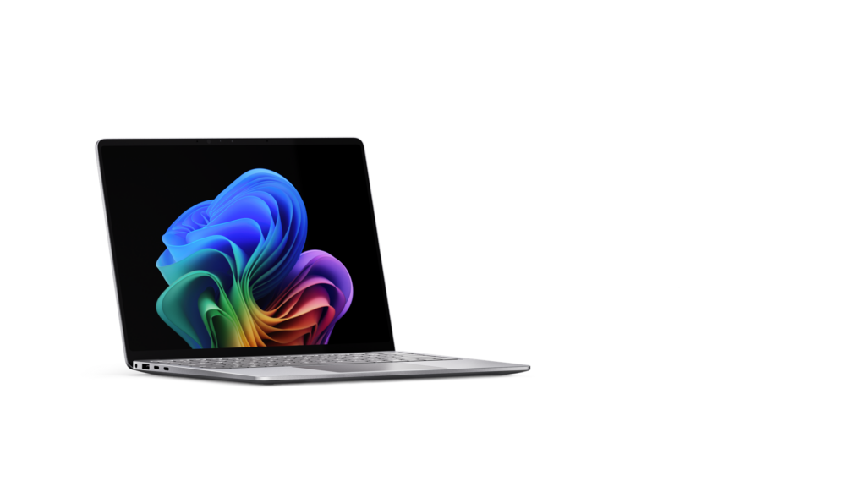
The new Surface Laptop for Business 13-inch is the most portable Surface Laptop, available starting today in select markets in 16GB and 24GB configurations starting at $1,499 (MSRP), with an 8GB configuration coming later this year starting at $1,299.99 (MSRP). With on-device AI processing, Wi-Fi 7[5] and a removable Gen 4 SSD designed for enterprise serviceability, it brings the full Surface experience to the entry-premium tier without asking IT or employees to trade off performance and productivity for portability.
The new Surface Laptop for Business, available in 13.8-inch and 15-inch, is designed for knowledge workers who move fast and expect their technology to keep pace, available starting today in select markets, starting at $1,949.99 (MSRP). Featuring an advanced haptic touchpad, stunning high-resolution touchscreen display and an optional integrated privacy screen with anti-glare on select configurations, it delivers a premium productivity experience wherever work happens. With up to 23 hours of battery life[4], Surface Laptop provides the performance and mobility professionals need to stay productive across offices, client sites and everywhere in between.
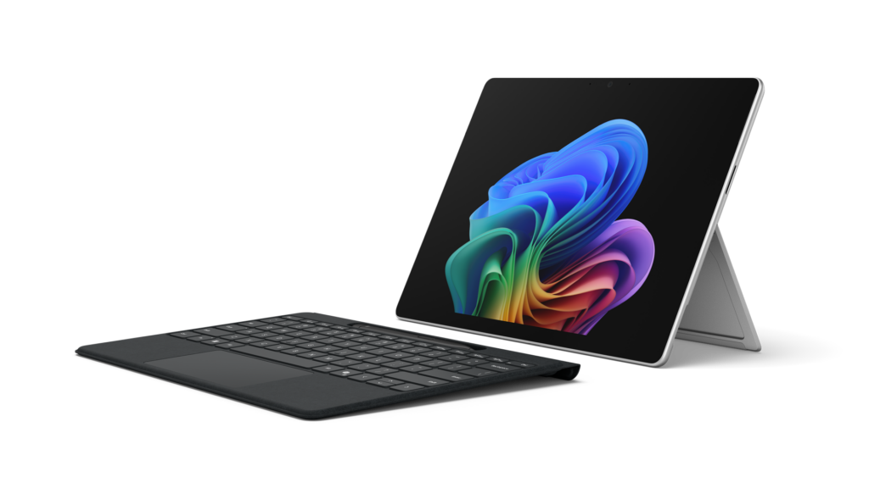
The new Surface Pro for Business 13-inch is thin, powerful and engineered to think as flexibly as your people do, available starting today in select markets, starting at $1,949.99 (MSRP). The 2-in-1 form-factor combines touch, voice, pen or keyboard input alongside on-device AI processing and laptop-level performance to meet the needs of users working on the go or at their desks with 5G options to keep them connected.[6]
Our team, relentless in building Surface PCs that meet the needs of businesses today and in the future, is driven by these three product-making principles.
- Security and trust are fundamental and should be built into every aspect of a device.
- Innovative devices are the platform that enables organizations to move faster with hybrid AI to accelerate workflows, productivity and end-to-end management.
- Intentional, functional and human centered design is imperative for hardware that supports how businesses work, with PCs that are built with a focus on reliability, sustainability and repairability features designed to keep employees productive and in their flow.
At Surface, security is a design principle baked in from the very first line of firmware code. Every new Surface for Business device ships as a Secured-core PC: enabling chip-to-cloud protection that is current, enforced[7] and aligned with your Microsoft security stack. Firmware updates are delivered through Windows Update without third-party complexity.
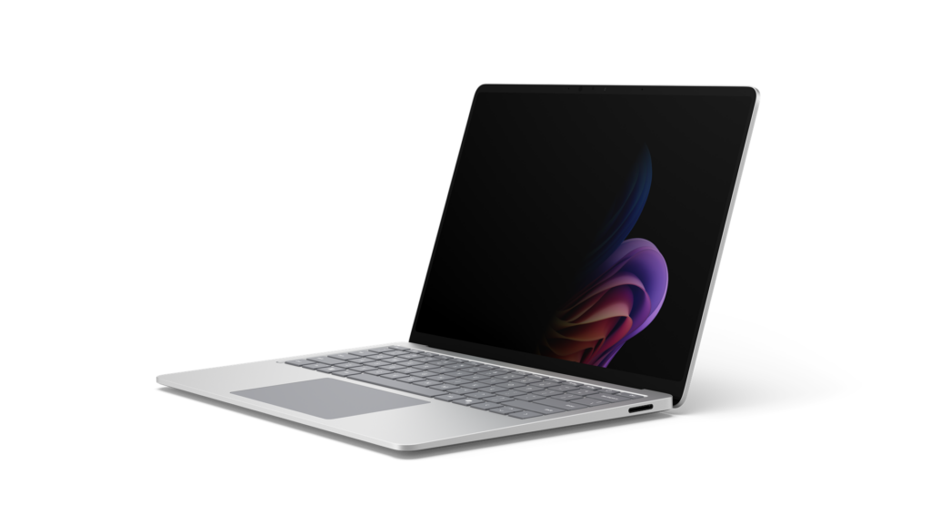
For the first time ever on a Surface device, we are introducing an optional integrated privacy screen with anti-glare. Built directly into select configurations of the 13.8-inch display of our Surface Laptop for Business, this software driven visual privacy filter helps protect sensitive information from unintended viewers and can be centrally managed by IT or activated instantly by employees with a single keystroke. Once activated, the privacy screen provides immediate protection from prying eyes without the need of a third-party physical screen protector. Designed from the ground up as part of our security-by-design approach, this innovation is made possible only by the tight integration of Surface hardware and software.
Surface is the first PC built on memory-safe firmware through our open-source Project Mu and Open Device Partnership (ODP) Unified Extensible Firmware Interface (UEFI), Rust-based drivers and secure embedded controller that is rooted in hardware-based protection, a direct response to one of the industry’s most persistent classes of vulnerabilities. When we say security is built in, we mean it at every layer of the stack.
Surface for Business devices are built for the future of AI. Whether you are running models in the cloud or on device, Surface devices are built to take advantage of both. That means features like real-time meeting transcription, intelligent writing assistance, select on-device image generation and live translation that work whether your employee is in a server room, on a plane or in a hospital ward.[8] For customers putting AI to work in real-world environments, that flexibility is already proving essential:
Surface allows us to run AI where learning happens, on the device itself. The future of AI is not everything going to the cloud; it’s AI at the edge.” — Eric Sedore, AVP and Chief Technology Officer, Syracuse University
For organizations building and deploying enterprise AI applications, Surface is also the reference platform for Windows AI APIs and the Foundry platform. Surface is purpose-built for developers who need a trusted, consistent hardware baseline, helping to enable on-device AI processing that can help offload everyday workloads from the cloud and optimize overall AI infrastructure costs at scale.
Surface for Business does not just transform the experience for employees, it transforms the experience for IT. From UEFI to browser, it can be managed through Microsoft Intune. Every device in this portfolio is built to support the end-to-end Microsoft stack: Microsoft Intune, Windows Autopilot and the Surface Management Portal give IT administrators a single, unified plane to provision devices at scale, enforce policies and manage the full device lifecycle including zero-touch deployment that gets people productive from day one.[7]
When the hardware, the operating system, the management platform and the productivity suite are all built and optimized by Microsoft, the result is not just operational efficiency, it’s a level of assurance and confidence that benefits the end-customers and businesses.
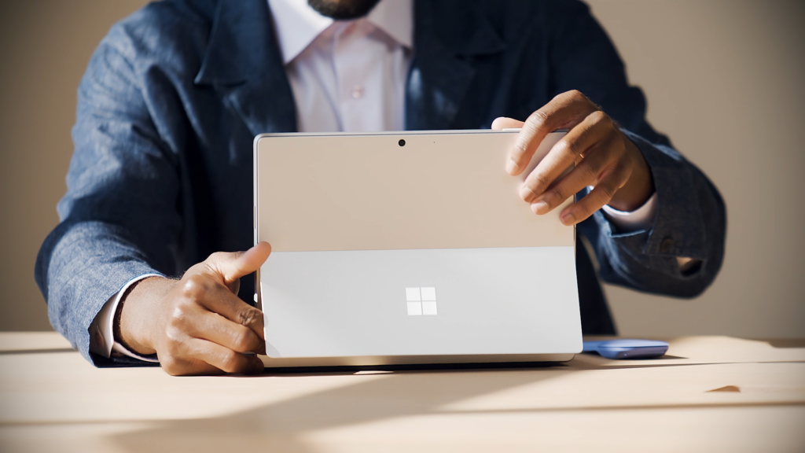
Surface designs PCs for how businesses work. The materials we choose in every Surface for Business device are not for appearance alone; we build PCs with durability in mind. Each is validated through years-worth of reliability testing[9] designed to simulate the real conditions of everyday professional use: the drops, the pressure, the temperature changes, the open-and-close cycles. The result is a device that stays strong, stays functional and stays looking great.
The Surface 3:2 display ratio is not an aesthetic choice, it is a productivity one. The vertical screen real estate from the display ratio means you can have two documents side by side without compromise, with multiple windows that give each app room to ensure productivity. Combined with anti-reflective display technology on select configurations. Surface displays are designed to reduce eye strain across long working days[10], because the best display is one that fades into the background, letting you focus on your work.
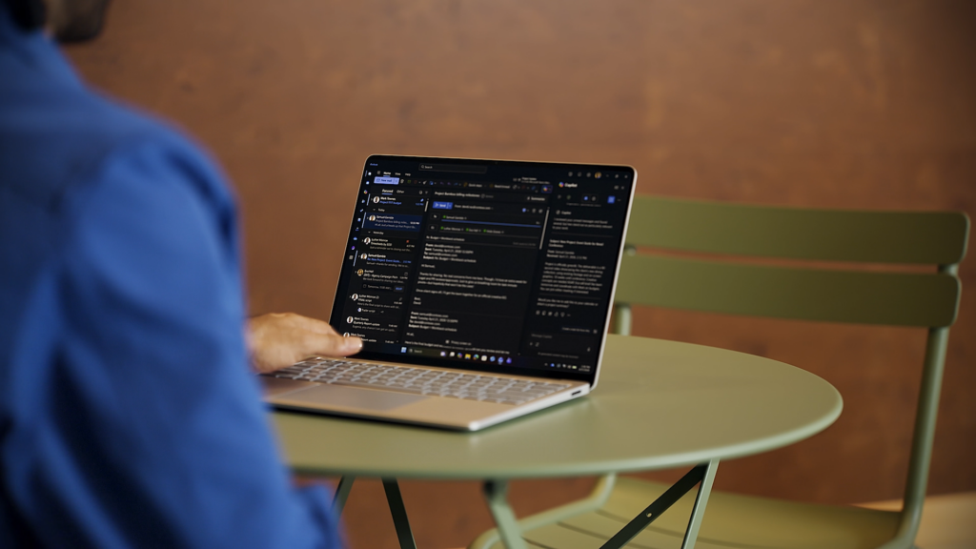
With advanced haptics, Surface Laptop for Business adds subtle, intelligent tactile feedback to the touchpad experience. From window snapping and resizing to dragging, dropping and navigating content, haptics reinforce intent across the operating system and through select third-party apps delivering a more precise, responsive and confidence inspiring experience.
Surface for Business devices are built with sustainability in mind. Surface Laptop, 13.8-inch and 15-inch, and Surface Pro 13-inch are made with a durable 100% recycled aluminum enclosure, reducing reliance on virgin materials[11].
These devices are built for high performance and energy efficiency. Each device is certified by ENERGY STAR, all outperforming the efficiency baseline by at least 45%[12]. Automatic Keyboard Backlight, a new setting enabled on Surface Laptop 13-inch, 13.8 and 15-inch, and Surface Pro 13-inch Keyboards, can help reduce power usage[13].
Surface for Business PCs are also designed for repairability, meaning less glue, and more access. Nearly every major device component across the Surface for Business portfolio is replaceable, backed by a robust parts supply chain so IT teams can source what they need quickly and keep devices in service longer. Repairs are designed for simplicity, clear visual wayfinding guides technicians through each step, and the process is engineered to be completed with commonly available tools. When repair is used instead of replacement a device can stay in the field longer, which helps maximize your investment and helps reduce waste. [14]
The AI PC cycle has already arrived. Organizations that move now will build the productivity advantage that compounds over time. Those that wait will find themselves closing a gap that only grows. Our team is continuing to innovate with devices designed for businesses to invest in an evolving future of computing. For a deeper dive on the newest Surface for Business PCs, read our Surface IT Pro blog.
Surface for Business gives you the clarity to act: a secure, AI-ready, beautifully designed portfolio, available today in select markets with Intel Core Ultra Series 3 and expanding later this year with Snapdragon X2. It is the full Microsoft stack, realized in hardware, ready for what comes next.
New Surface Pro for Business and Surface Laptop for Business are available today at Surface for Business and through Microsoft authorized commercial resellers.
[1] Tested by Microsoft April 2026 using CineBench 2024 Multi-Core benchmark comparing Surface Laptop for Business, 13.8 and 15-inch with Intel Core Ultra X7 to MacBook Air, 13.5-inch, M5 Chip, 10 Core CPU.
[2] Tested by Microsoft April 2026 using CineBench 2024 Multi-Core benchmark. Up to 95% faster comparing Surface Laptop, 15-inch with Intel Core Ultra X7 to Surface Laptop 5 15-inch with Intel Core i7. Up to 93% faster comparing Surface Laptop for Business 13.8-inch with Intel Core Ultra X7 processors to Surface Laptop 5 13.5-inch with Intel Core i7.
[3] Tested by Microsoft April 2026 using Procyon AI benchmark comparing Surface Laptop, 13.8-inch and 15-inch (8th Edition) with Snapdragon to Surface Laptop, 13.8-inch and 15-inch (7th Edition) with Snapdragon. Performance varies by configuration.
[4] Based on local video playback test. Battery life varies significantly based on usage, network and feature configuration, signal strength, settings and other factors. See aka.ms/SurfaceBatteryPerformance for details.
[5] 6GHz band not available in all regions.
[6] 5G not available in all areas. Compatibility and performance depend on carrier network, plan and other factors. See carrier for details and pricing.
[7] Software license required for some features. Sold separately
[8] Feature availability and performance may vary by device, configuration and region. Some AI experiences require internet connection, compatible hardware or Microsoft 365 subscription.
[9] Reliability testing conducted under controlled laboratory conditions. Testing does not promise or guarantee future performance under the same conditions in the real world. Customer induced damage or use beyond normal use conditions is not covered under Microsoft’s Limited Hardware Warranty.
[10] The Surface Laptop for Business with Intel displays has been designed to minimize unwanted reflections and has been certified by TÜV SÜD to meet the requirements of ISO 9241-307.
[11] Surface Pro for Business, 13-inch enclosure includes bucket, kickstand. 86% recycled content in the enclosure, consisting of 100% recycled aluminum alloy in bucket, and 100% recycled rare earth metals in the magnets. Surface Laptop for Business, 13.8-inch and 15-inch, enclosure includes A Cover and C Bucket. 64% recycled content in the enclosure, consisting of 100% recycled aluminum alloy in A Cover and C Bucket, and 100% recycled rare earth metals in the magnets. Based on validation performed by Underwriter Laboratories, Inc. using Environmental Claim Validation Procedure (ECVP) for Recycled Content, UL ECVP 2809-2, Second Edition, dated June 2024.
[12] Comparison based on product energy consumption vs. ENERGY STAR certification limits for personal computers. Actual performance varies by configuration and usage.
[13] Compared to typical use without the feature enabled. Actual power savings vary based on usage, settings, ambient lighting and other factors. Not supported with wireless detach on Surface Pro 13-inch Flex Keyboard.
[14] Replacement components available through Surface Commercial authorized device resellers. Components can be replaced on-site by a skilled technician following Microsoft’s Service Guide. Microsoft tools (sold separately) may also be required. Availability of replacement components and service options may vary by product, market and over time. See Surface service options – Surface | Microsoft Learn. Opening and/or repairing your device can present electric shock, fire and personal injury risks and other hazards. Use caution if undertaking do-it-yourself repairs. Unless required by law, device damage caused during repair will not be covered under Microsoft’s Hardware Warranty or protection plans.

From <https://blogs.windows.com/devices/2026/05/19/introducing-new-surface-devices-built-for-business-and-ai-acceleration/>
DATE OF UPDATE: 5.21.2026
Special Pricing
- All NEW submissions will have an expiration of 7/31
- For approvals expiring June 30th, please escalate in for extension to 7/31 where needed
- Eligibili

